UNITED STATES
SECURITIES AND EXCHANGE COMMISSION
Washington, D.C. 20549

FORM 8-K

CURRENT REPORT
Pursuant to Section 13 or 15(d) of the Securities Exchange Act of 1934

September 24, 2026
Date of Report (Date of earliest event reported)

CHARLES RIVER LABORATORIES INTERNATIONAL, INC.
(Exact Name of Registrant as Specified in Charter)
Delaware |  |  |  |  |  |  |  |  | 001-15943 |  |  |  |  |  |  |  |  | 06-1397316
(State or Other  Jurisdiction of Incorporation) |  |  |  |  |  |  |  |  | (Commission File Number) |  |  |  |  |  |  |  |  | (IRS Employer  Identification No.)

251 Ballardvale Street
Wilmington, Massachusetts 01887
(Address of Principal Executive Offices) (Zip Code)

781-222-6000
(Registrant’s Telephone Number, including Area Code)

Securities registered pursuant to Section 12(b) of the Act:
Title of each class |  |  |  |  |  |  |  |  | Trading Symbol(s) |  |  |  |  |  |  |  |  | Name of each exchange on which registered
Common stock, $0.01 par value |  |  |  |  |  |  |  |  | CRL |  |  |  |  |  |  |  |  | New York Stock Exchange
Check the appropriate box below if the Form 8-K filing is intended to simultaneously satisfy the filing obligation of the registrant under any of the following provisions:
☐ |  |  |  |  |  |  |  |  | Written communications pursuant to Rule 425 under the Securities Act (17 CFR 230.425)
☐ |  |  |  |  |  |  |  |  | Soliciting material pursuant to Rule 14a-12 under the Exchange Act (17 CFR 240.14a-12)
☐ |  |  |  |  |  |  |  |  | Pre-commencement communications pursuant to Rule 14d-2(b) under the Exchange Act (17 CFR 240.14d-2(b))
☐ |  |  |  |  |  |  |  |  | Pre-commencement communications pursuant to Rule 13e-4(c) under the Exchange Act (17 CFR 240.13e-4(c))

Indicate by check mark whether the registrant is an emerging growth company as defined in Rule 405 of the Securities Act of 1933 (17 CFR §230.405) or Rule 12b-2 of the Securities Exchange Act of 1934 (17 CFR §240.12b-2).

Emerging growth company ☐

If an emerging growth company, indicate by check mark if the registrant has elected not to use the extended transition period for complying with any new or revised financial accounting standards provided pursuant to Section 13(a) of the Exchange Act. ☐

ITEM 7.01. Regulation FD Disclosure
On September 24, 2026, in connection with its Investor Day, Charles River Laboratories International, Inc. (the “Company”) issued a press release that, among other things, discusses its business strategy, reaffirms its full-year 2026 guidance, and provides its long-term financial targets through 2030. A copy of the press release is furnished as Exhibit 99.1 hereto and incorporated by reference herein.

The Company will host its Investor Day beginning at 9:00 a.m. Eastern time today, which will be live webcast and archived on the Company’s Investor Relations website. To access the webcast and corresponding slide presentation, visit http://ir.criver.com. The slide presentation is not incorporated herein by reference.

The information contained in this item and item 9.01, including Exhibit 99.1, is furnished to the Commission, but shall not be deemed “filed” with the Commission for purposes of Section 18 of the Securities Exchange Act of 1934 (“Exchange Act”), or incorporated by reference in any filing under the Exchange Act or the Securities Act of 1933, except as expressly stated in any such filing. Information included on the Company’s website shall not be deemed to be incorporated into this Current Report on Form 8-K.
The statements in the Investor Day press release and related presentation materials which are not historical facts may be forward-looking statements. Readers are cautioned not to place undue reliance on forward-looking statements, which speak only as of the date that they are made and which reflect management's current estimates, projections, expectations or beliefs and which involve risks and uncertainties that could cause actual results and outcomes to be materially different. Those risks and uncertainties include, but are not limited to, the ability to execute on, the results, and the impact of the Company’s Pathway to Purpose strategy and related initiatives. Furthermore, these and other risks relating to the Company are set forth in the documents filed by the Company with the Commission, including without limitation, the Risk Factors in the Company’s Annual Report on Form 10-K filed February 18, 2026, as well as the Company’s other filings with the Commission.

ITEM 9.01. Financial Statements and Exhibits
(d) Exhibits.

Exhibit No. |  |  |  |  |  |  |  |  |  |  |  |  |  |  |  |  |  | Description
99.1 |  |  |  |  |  |  |  |  |  |  |  |  |  |  |  |  |  | Press release dated September 24, 2026
104 |  |  |  |  |  |  |  |  |  |  |  |  |  |  |  |  |  | Cover Page Interactive Data File (embedded within the Inline XBRL document)

SIGNATURES
Pursuant to the requirements of the Securities Exchange Act of 1934, the registrant has duly caused this report to be signed on its behalf by the undersigned hereunto duly authorized.

 |  |  |  |  |  |  |  |  |  |  |  |  |  |  |  |  |  |  |  |  |  |  |  |  |  |  | CHARLES RIVER LABORATORIES INTERNATIONAL, INC.
Date: |  |  |  |  |  |  |  |  | September 24, 2026 |  |  |  |  |  |  |  |  | By: |  |  |  |  |  |  |  |  | /s/ Kerry Dailey
Kerry Dailey
Corporate Senior Vice President and Chief Legal Officer

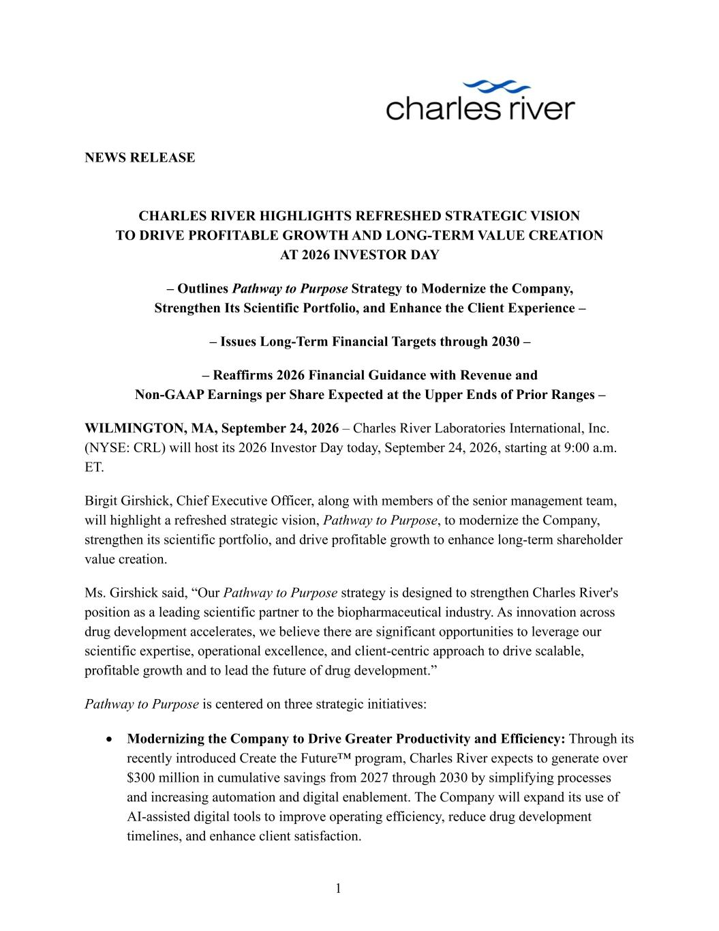

1 NEWS RELEASE CHARLES RIVER HIGHLIGHTS REFRESHED STRATEGIC VISION TO DRIVE PROFITABLE GROWTH AND LONG-TERM VALUE CREATION AT 2026 INVESTOR DAY – Outlines Pathway to Purpose Strategy to Modernize the Company, Strengthen Its Scientific Portfolio, and Enhance the Client Experience – – Issues Long-Term Financial Targets through 2030 – – Reaffirms 2026 Financial Guidance with Revenue and Non-GAAP Earnings per Share Expected at the Upper Ends of Prior Ranges – WILMINGTON, MA, September 24, 2026 – Charles River Laboratories International, Inc. (NYSE: CRL) will host its 2026 Investor Day today, September 24, 2026, starting at 9:00 a.m. ET. Birgit Girshick, Chief Executive Officer, along with members of the senior management team, will highlight a refreshed strategic vision, Pathway to Purpose, to modernize the Company, strengthen its scientific portfolio, and drive profitable growth to enhance long-term shareholder value creation. Ms. Girshick said, “Our Pathway to Purpose strategy is designed to strengthen Charles River's position as a leading scientific partner to the biopharmaceutical industry. As innovation across drug development accelerates, we believe there are significant opportunities to leverage our scientific expertise, operational excellence, and client-centric approach to drive scalable, profitable growth and to lead the future of drug development.” Pathway to Purpose is centered on three strategic initiatives: • Modernizing the Company to Drive Greater Productivity and Efficiency: Through its recently introduced Create the Future™ program, Charles River expects to generate over $300 million in cumulative savings from 2027 through 2030 by simplifying processes and increasing automation and digital enablement. The Company will expand its use of AI-assisted digital tools to improve operating efficiency, reduce drug development timelines, and enhance client satisfaction.

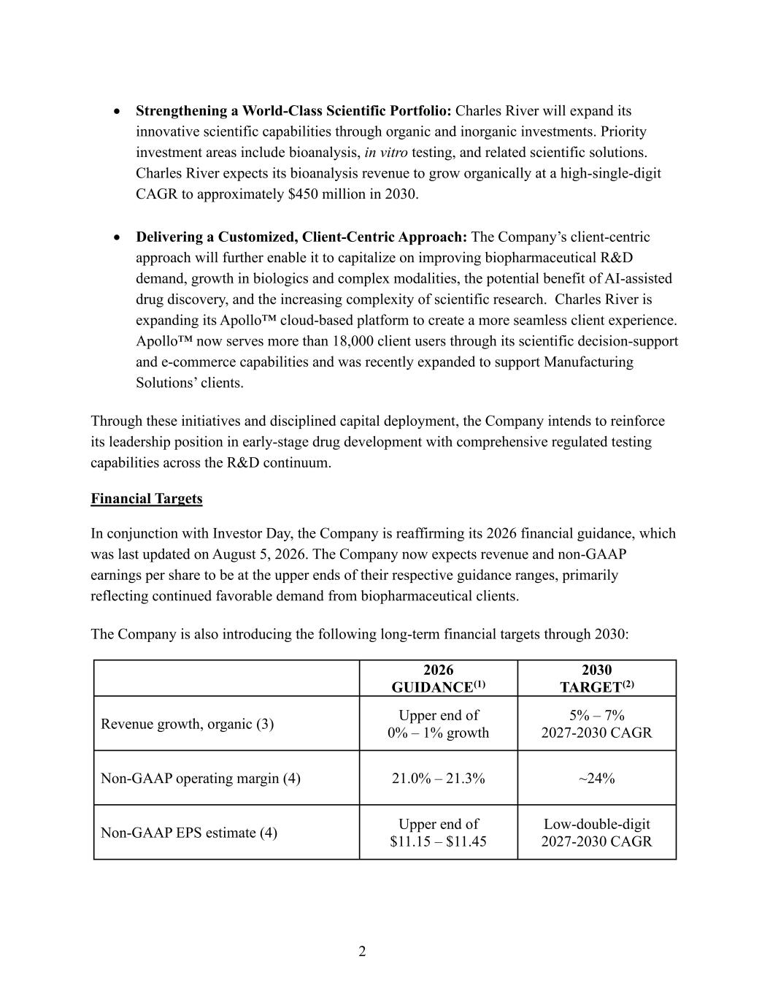
2 • Strengthening a World-Class Scientific Portfolio: Charles River will expand its innovative scientific capabilities through organic and inorganic investments. Priority investment areas include bioanalysis, in vitro testing, and related scientific solutions. Charles River expects its bioanalysis revenue to grow organically at a high-single-digit CAGR to approximately $450 million in 2030. • Delivering a Customized, Client-Centric Approach: The Company’s client-centric approach will further enable it to capitalize on improving biopharmaceutical R&D demand, growth in biologics and complex modalities, the potential benefit of AI-assisted drug discovery, and the increasing complexity of scientific research. Charles River is expanding its Apollo™ cloud-based platform to create a more seamless client experience. Apollo™ now serves more than 18,000 client users through its scientific decision-support and e-commerce capabilities and was recently expanded to support Manufacturing Solutions’ clients. Through these initiatives and disciplined capital deployment, the Company intends to reinforce its leadership position in early-stage drug development with comprehensive regulated testing capabilities across the R&D continuum. Financial Targets In conjunction with Investor Day, the Company is reaffirming its 2026 financial guidance, which was last updated on August 5, 2026. The Company now expects revenue and non-GAAP earnings per share to be at the upper ends of their respective guidance ranges, primarily reflecting continued favorable demand from biopharmaceutical clients. The Company is also introducing the following long-term financial targets through 2030: 2026 GUIDANCE(1) 2030 TARGET(2) Revenue growth, organic (3) Upper end of 0% – 1% growth 5% – 7% 2027-2030 CAGR Non-GAAP operating margin (4) 21.0% – 21.3% ~24% Non-GAAP EPS estimate (4) Upper end of $11.15 – $11.45 Low-double-digit 2027-2030 CAGR

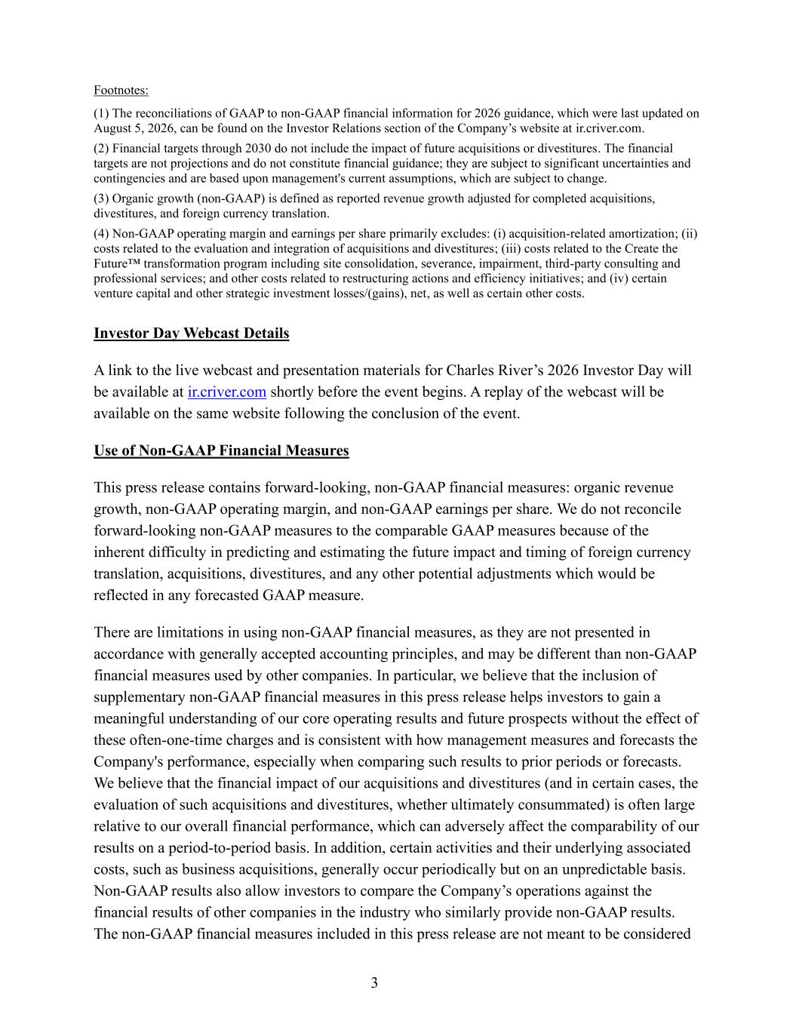
3 Footnotes: (1) The reconciliations of GAAP to non-GAAP financial information for 2026 guidance, which were last updated on August 5, 2026, can be found on the Investor Relations section of the Company’s website at ir.criver.com. (2) Financial targets through 2030 do not include the impact of future acquisitions or divestitures. The financial targets are not projections and do not constitute financial guidance; they are subject to significant uncertainties and contingencies and are based upon management's current assumptions, which are subject to change. (3) Organic growth (non-GAAP) is defined as reported revenue growth adjusted for completed acquisitions, divestitures, and foreign currency translation. (4) Non-GAAP operating margin and earnings per share primarily excludes: (i) acquisition-related amortization; (ii) costs related to the evaluation and integration of acquisitions and divestitures; (iii) costs related to the Create the Future™ transformation program including site consolidation, severance, impairment, third-party consulting and professional services; and other costs related to restructuring actions and efficiency initiatives; and (iv) certain venture capital and other strategic investment losses/(gains), net, as well as certain other costs. Investor Day Webcast Details A link to the live webcast and presentation materials for Charles River’s 2026 Investor Day will be available at ir.criver.com shortly before the event begins. A replay of the webcast will be available on the same website following the conclusion of the event. Use of Non-GAAP Financial Measures This press release contains forward-looking, non-GAAP financial measures: organic revenue growth, non-GAAP operating margin, and non-GAAP earnings per share. We do not reconcile forward-looking non-GAAP measures to the comparable GAAP measures because of the inherent difficulty in predicting and estimating the future impact and timing of foreign currency translation, acquisitions, divestitures, and any other potential adjustments which would be reflected in any forecasted GAAP measure. There are limitations in using non-GAAP financial measures, as they are not presented in accordance with generally accepted accounting principles, and may be different than non-GAAP financial measures used by other companies. In particular, we believe that the inclusion of supplementary non-GAAP financial measures in this press release helps investors to gain a meaningful understanding of our core operating results and future prospects without the effect of these often-one-time charges and is consistent with how management measures and forecasts the Company's performance, especially when comparing such results to prior periods or forecasts. We believe that the financial impact of our acquisitions and divestitures (and in certain cases, the evaluation of such acquisitions and divestitures, whether ultimately consummated) is often large relative to our overall financial performance, which can adversely affect the comparability of our results on a period-to-period basis. In addition, certain activities and their underlying associated costs, such as business acquisitions, generally occur periodically but on an unpredictable basis. Non-GAAP results also allow investors to compare the Company’s operations against the financial results of other companies in the industry who similarly provide non-GAAP results. The non-GAAP financial measures included in this press release are not meant to be considered

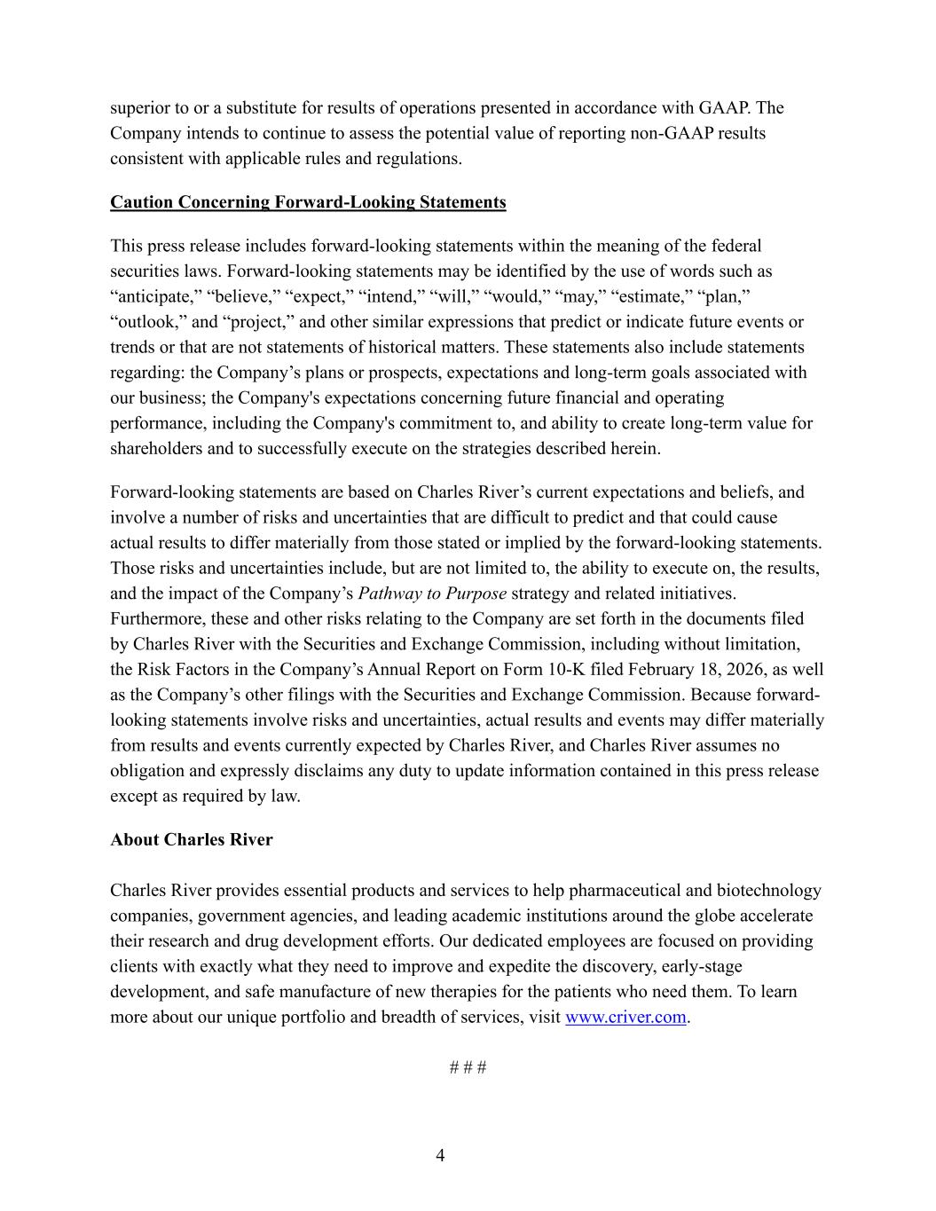
4 superior to or a substitute for results of operations presented in accordance with GAAP. The Company intends to continue to assess the potential value of reporting non-GAAP results consistent with applicable rules and regulations. Caution Concerning Forward-Looking Statements This press release includes forward-looking statements within the meaning of the federal securities laws. Forward-looking statements may be identified by the use of words such as “anticipate,” “believe,” “expect,” “intend,” “will,” “would,” “may,” “estimate,” “plan,” “outlook,” and “project,” and other similar expressions that predict or indicate future events or trends or that are not statements of historical matters. These statements also include statements regarding: the Company’s plans or prospects, expectations and long-term goals associated with our business; the Company's expectations concerning future financial and operating performance, including the Company's commitment to, and ability to create long-term value for shareholders and to successfully execute on the strategies described herein. Forward-looking statements are based on Charles River’s current expectations and beliefs, and involve a number of risks and uncertainties that are difficult to predict and that could cause actual results to differ materially from those stated or implied by the forward-looking statements. Those risks and uncertainties include, but are not limited to, the ability to execute on, the results, and the impact of the Company’s Pathway to Purpose strategy and related initiatives. Furthermore, these and other risks relating to the Company are set forth in the documents filed by Charles River with the Securities and Exchange Commission, including without limitation, the Risk Factors in the Company’s Annual Report on Form 10-K filed February 18, 2026, as well as the Company’s other filings with the Securities and Exchange Commission. Because forward- looking statements involve risks and uncertainties, actual results and events may differ materially from results and events currently expected by Charles River, and Charles River assumes no obligation and expressly disclaims any duty to update information contained in this press release except as required by law. About Charles River Charles River provides essential products and services to help pharmaceutical and biotechnology companies, government agencies, and leading academic institutions around the globe accelerate their research and drug development efforts. Our dedicated employees are focused on providing clients with exactly what they need to improve and expedite the discovery, early-stage development, and safe manufacture of new therapies for the patients who need them. To learn more about our unique portfolio and breadth of services, visit www.criver.com. # # #


5 Investor Contact: Media Contact: Todd Spencer Amy Cianciaruso Corporate Vice President, Corporate Senior Vice President, Investor Relations Chief Communications Officer 781.222.6455 781.222.6168 todd.spencer@crl.com amy.cianciaruso@crl.com

